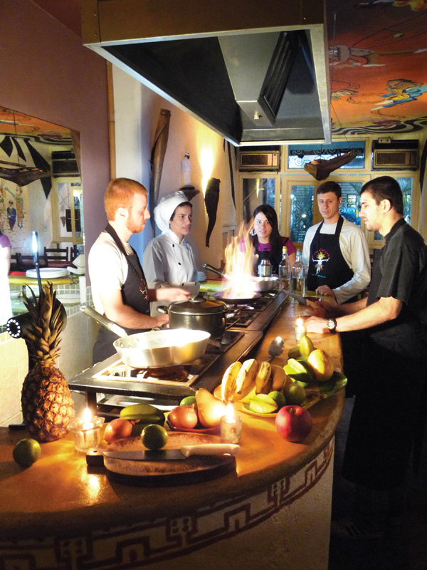

Price-sheet:
1-Day Brazilian cooking class

Supplier: Cook in Rio
Service: 1-day Brazilian cooking class to international tourists in groups of 2 to 14 pax.
Suggested Menu: Bahian Moqueca Experience
- Welcome drink: Batida de Coco / tropical juice.
- Quick intro to Brazilian culinary history
- Cassava nutrional facts
- Fried cassava sticks lesson and tasting
- Batida de Coco (coconut alcoholic drink) lesson and tasting
- Pé de Moleque lesson (peanut brittle)
- Moqueca intro
- Moqueca lesson (fish, vegetarian or shrimp)
- Caipirinha in various fruits, lesson and tasting
- Main meal: moqueca with Rice and farofa followed by Pe de Moleque dessert.

Alternative menu: Feijoada Ritual (similar to moqueca menu, except with feijoada instead of moqueca)
EXCLUSIVE CLASSES FOR YOUR GROUP
STUDENTS | 2 | 4 | 6 | 8 | 10 | 12 | 14
NET PRICE PER STUDENT (R$) | 160 | 140 | 130 | 120 | 110 | 100 | 90
TOTAL (R$)* | 320 | 560 | 780 | 960 | 1100 | 1200 | 1260

OPEN CLASSES | (LAST MINUTE FIT-IN IN EXISTING CLASSES WITH OTHER STUDENTS.)
STUDENTS | 2 | 4 | 6 | 8 | 10 | 12 | X
NET PRICE PER STUDENT (R$) | 100 | 100 | 100 | 100 | 100 | 100 | X
TOTAL (R$)* | 200 | 400 | 600 | 800 | 1000 | 1200 | X

*Prices valid till 1 june 2011. $ in Brazilian Reals.
Languages: English, Portuguese, Spanish and German
Class schedule:
- Late-lunch: 2pm to 6pm
- Dinner: 7pm to 11pm
From Monday to Saturday

Address: Rua Ronald de Carvalho 154 Copacabana (Restaurante Tasca do Lido)
Site: www.cookinrio.com
E-mail: info@cookinrio.com
Business contact: Cristiano Lemos Instructor: Simone Theisen
Telephone: Cristiano Lemos = (+55 21) 8894 9857 or Simone = (21) 8761 3653 or (21) 2247-5674

